Justin Cray

04/17/18

AMRUPT, SP18

**Goals**

My goals for this week were to figure out the clock and noise cards on the coherent-receiver setup. I also installed GNU Radio on my computer since I was with Russell while he was working on I/Q extraction.

**Problem**

I was unsure how much validation to do, since we don’t have the noise card and I am unsure what the clock specs we need are.

**General Approach**

My first step was to look into the functionality of the noise cards and the clock card and then identify a way of validating their functionality.

For the clock card, I simply removed the small connectors on the RTL-SDR boards and probed the clock signals which the boards were receiving.

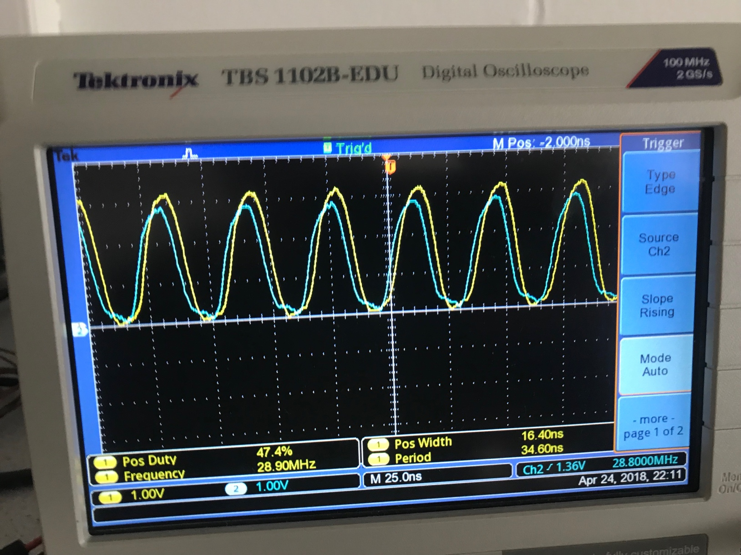

You can see an approx 2 ns delay between the signals. While I’m not quite confident whether this is sufficient or not for coherent detection, it seems like it’s close enough. This seems like it would be in the normal range of operational and consistent with the setup in the video where it works.

The noise cards were a little harder to understand. While we don’t have the noise cards currently, we do have the noise expander card. The Noise Generator Expansion Card (NG_ExpCARD) is designed to distribute the noise signal when the number of channels in the coherent receiver is greater than four. This should not be necessary for our initial design, as the noise generator card also has four outputs according to the coherent-receiver website. Nonetheless it can’t hurt to have I guess.

**Planned Course of Action**

I think the next step is to really double down on the work with Russell and Peidong to get coherent detection working since it seems we now understand all the hardware functionality and validated that it works properly.